CHECKOUT TABLE

USE [Shopping]
GO

/****** Object: Table [dbo].[CheckOut] Script Date: 4/19/2023 7:36:26 PM ******/
SET ANSI_NULLS ON
GO

SET QUOTED_IDENTIFIER ON
GO

CREATE TABLE [dbo].[CheckOut](
[Date] [datetime] NULL,
[Quantity] [int] NULL,
[ActivationCode] [varchar](max) NOT NULL,
[ProductID] [int] NULL,
[CustomerID] [int] NULL
) ON [PRIMARY] TEXTIMAGE_ON [PRIMARY]
GO

ALTER TABLE [dbo].[CheckOut] WITH CHECK ADD CONSTRAINT [FK__CheckOut__Custom__6B24EA82] FOREIGN KEY([CustomerID])
REFERENCES [dbo].[Customer] ([Id])
GO

ALTER TABLE [dbo].[CheckOut] CHECK CONSTRAINT [FK__CheckOut__Custom__6B24EA82]
GO

ALTER TABLE [dbo].[CheckOut] WITH CHECK ADD CONSTRAINT [FK__CheckOut__Produc__6A30C649] FOREIGN KEY([ProductID])
REFERENCES [dbo].[Product] ([ProductID])
GO

ALTER TABLE [dbo].[CheckOut] CHECK CONSTRAINT [FK__CheckOut__Produc__6A30C649]
GO

CheckOut Table when User Hit the CheckOut button
Their purchases will be stored
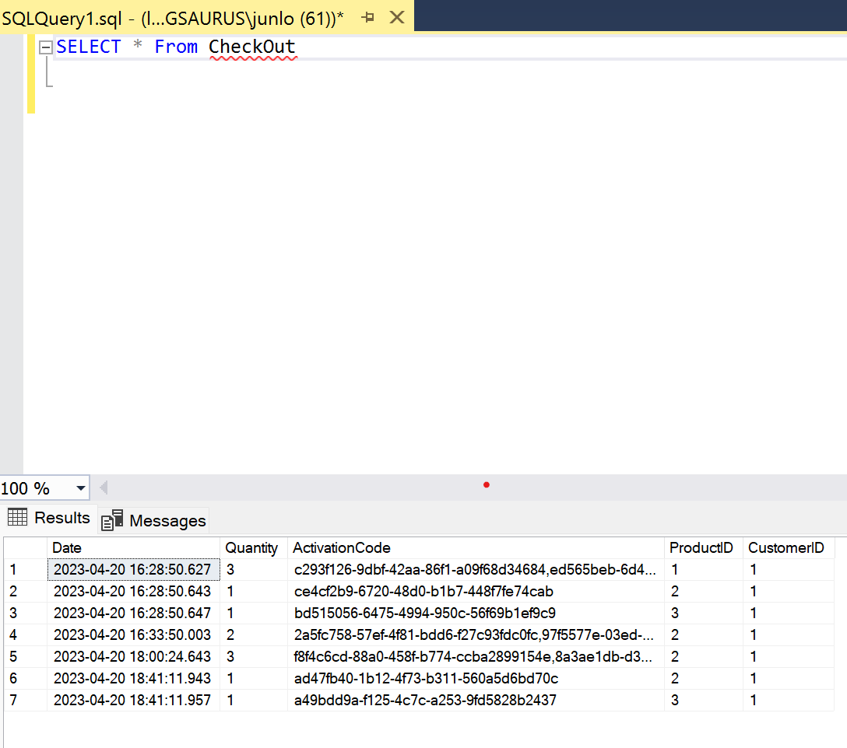

CUSTOMER TABLE

USE [Shopping]
GO

/****** Object: Table [dbo].[Customer] Script Date: 4/19/2023 7:37:41 PM ******/
SET ANSI_NULLS ON
GO

SET QUOTED_IDENTIFIER ON
GO

CREATE TABLE [dbo].[Customer](
[Id] [int] NOT NULL,
[Username] [varchar](50) NOT NULL,
[Password] [varchar](50) NOT NULL,
CONSTRAINT [PK_Customer] PRIMARY KEY CLUSTERED
(
[Id] ASC
)WITH (PAD_INDEX = OFF, STATISTICS_NORECOMPUTE = OFF, IGNORE_DUP_KEY = OFF, ALLOW_ROW_LOCKS = ON, ALLOW_PAGE_LOCKS = ON, OPTIMIZE_FOR_SEQUENTIAL_KEY = OFF) ON [PRIMARY]
) ON [PRIMARY]
GO

Data for Customer Table

insert into Customer values (1, 'admin1', 'admin1' ),
(2, 'admin2', 'admin2' ),
(3, 'admin3','admin3')

Customer Table
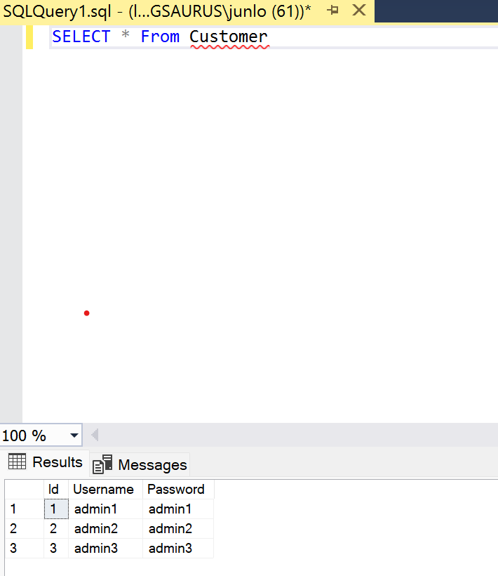

PRODUCT TABLE

USE [Shopping]
GO

/****** Object: Table [dbo].[Product] Script Date: 4/19/2023 7:38:01 PM ******/
SET ANSI_NULLS ON
GO

SET QUOTED_IDENTIFIER ON
GO

CREATE TABLE [dbo].[Product](
[ProductID] [int] NOT NULL,
[Name] [varchar](50) NOT NULL,
[Description] [varchar](max) NOT NULL,
[Price] [int] NOT NULL,
[Image] [varchar](max) NOT NULL,
[ReviewCount] [int] NOT NULL,
[CountClick] [int] NOT NULL,
CONSTRAINT [PK_Product] PRIMARY KEY CLUSTERED
(
[ProductID] ASC
)WITH (PAD_INDEX = OFF, STATISTICS_NORECOMPUTE = OFF, IGNORE_DUP_KEY = OFF, ALLOW_ROW_LOCKS = ON, ALLOW_PAGE_LOCKS = ON, OPTIMIZE_FOR_SEQUENTIAL_KEY = OFF) ON [PRIMARY]
) ON [PRIMARY] TEXTIMAGE_ON [PRIMARY]
GO

Data for Product Table
insert into Product values ('1','.NET Charts','Bring powerful capabilities to your .NET application','99','/lightningchart.com/wp-content/uploads/images/homepage/lightningchart-.net-icon.svg','0', '0');
insert into Product values ('2','.NET Paypal','Integrate your .NET app with paypal the easy way','69','/encrypted-tbn0.gstatic.com/images?q=tbn:ANd9GcS-zxUrvTnb8Mp1G7txV8xhMihICxjyXjGmcw&usqp=CAU','0', '0');
insert into Product values ('3','.NET ML','Supercharged .NET machine learning libraries','299','/devblogs.microsoft.com/dotnet/wp-content/uploads/sites/10/2019/08/mlnet-icon.png','0', '0');
insert into Product values ('4','.NET Analytics','Performed data mining and analytics easily in .NET','299','/s.pngkit.com/png/small/138-1386225_hi-res-analytics-smart-data-analytics-suggestions-png.png','0', '0');
insert into Product values ('5','.NET Logger','Logs and aggregates event easily in your .NET apps','49','/icon-library.com/images/data-log-icon/data-log-icon-8.jpg','0', '0');
insert into Product values ('6','.NET Numerics','Powerful numerical methods for your .NET simulations','199','/static.thenounproject.com/png/2248444-200.png','0', '0')

Product Table

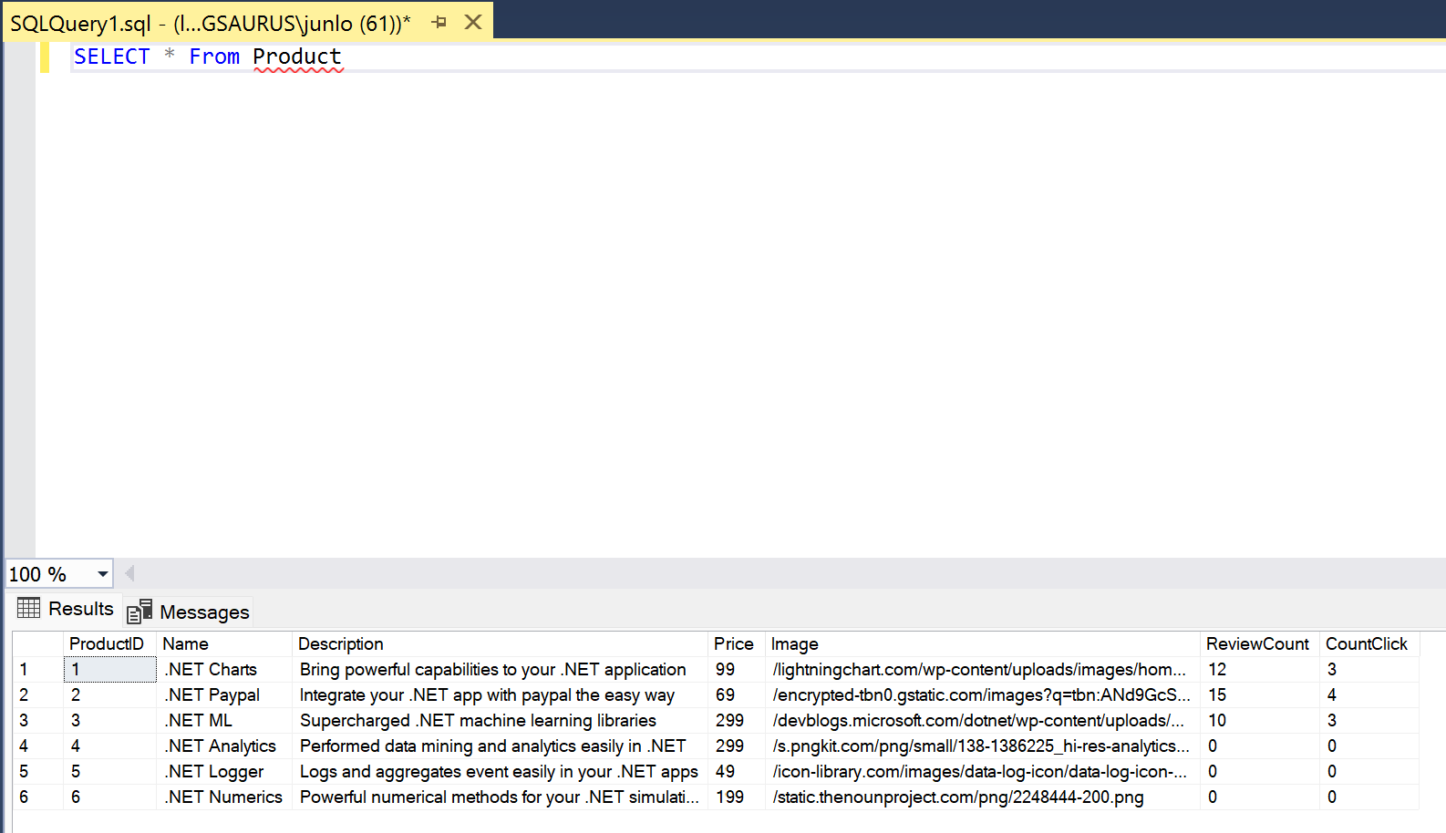

PURCHASE TABLE

USE [Shopping]
GO

/****** Object: Table [dbo].[Purchase] Script Date: 4/19/2023 7:38:21 PM ******/
SET ANSI_NULLS ON
GO

SET QUOTED_IDENTIFIER ON
GO

CREATE TABLE [dbo].[Purchase](
[ProductID] [int] NOT NULL,
[CustomerID] [int] NOT NULL,
[NumberOfPurchase] [int] NULL,
PRIMARY KEY CLUSTERED
(
[ProductID] ASC,
[CustomerID] ASC
)WITH (PAD_INDEX = OFF, STATISTICS_NORECOMPUTE = OFF, IGNORE_DUP_KEY = OFF, ALLOW_ROW_LOCKS = ON, ALLOW_PAGE_LOCKS = ON, OPTIMIZE_FOR_SEQUENTIAL_KEY = OFF) ON [PRIMARY]
) ON [PRIMARY]
GO

ALTER TABLE [dbo].[Purchase] WITH CHECK ADD CONSTRAINT [FK__Purchase__Produc__5EBF139D] FOREIGN KEY([ProductID])
REFERENCES [dbo].[Product] ([ProductID])
GO

ALTER TABLE [dbo].[Purchase] CHECK CONSTRAINT [FK__Purchase__Produc__5EBF139D]
GO

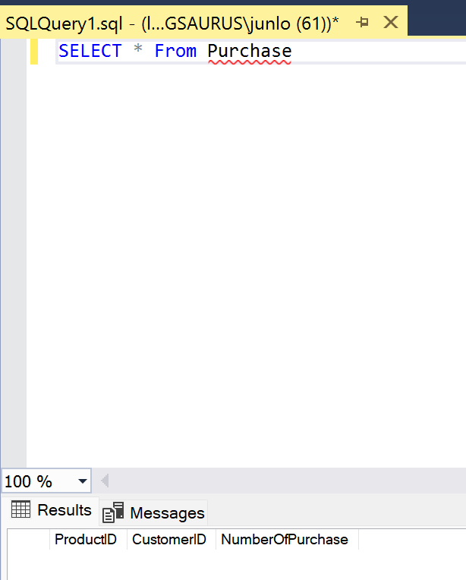 Purchase Table to store Data added to Cart

VIEWCART TABLE

USE [Shopping]
GO

/****** Object: Table [dbo].[ViewCart] Script Date: 4/19/2023 7:38:38 PM ******/
SET ANSI_NULLS ON
GO

SET QUOTED_IDENTIFIER ON
GO

CREATE TABLE [dbo].[ViewCart](
[ProductID] [int] NOT NULL,
[NumberOfPurchase] [int] NULL,
[Name] [varchar](50) NULL,
[Description] [varchar](max) NULL,
[Price] [int] NULL,
[Image] [varchar](max) NULL
) ON [PRIMARY] TEXTIMAGE_ON [PRIMARY]
GO

ViewCart Table
